**How to add yourself to your UO Steam friends list.**

One advantage of using UO Steam over Razor is its ability to run a bandage subroutine at the same time as running macros. Using this feature is handy for players that are not geared enough to handle a champ spawn without the aid of friends.

To use this feature, bring up the UO Steam window. Under the Options tab, choose the Friends tab.

* **Bandage Self option**

On the right in the Healing Box, are all the options for who and how you heal them. Notice on the drop down block, there is the option to just heal [Self]. Choosing self will cause this to only heal yourself.

*\*\*\*In order to run this feature, you must check mark the box that says Enabled as shown below.\*\*\**

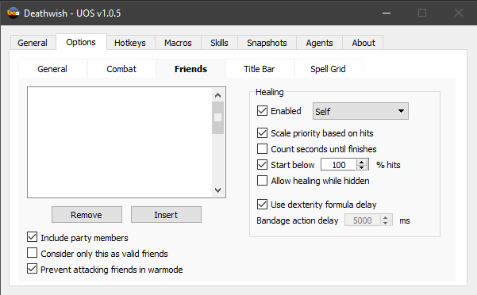

One notable option on the right side is ‘Use dexterity formula delay’. This is important because based on your characters dex stat, the time it takes to heal yourself can vary between 4-8 seconds. Since a lot of monsters cast spells like Feeble and Curse, it can change how fast you finish using a bandage. So, instead of using a flat time (in the example above, 5000 ms/ 5 seconds), place a check mark in the box and it will automatically adjust when to start another bandage if needed.

* **Bandage Friend option**

The big white box on the left is a list that displays the name and serial numbers of players and pets that UO Steam will heal when standing next to. To add someone to the list simply click the [Insert] button and then on your game screen, target who you want to add to your list. After you are done, you have to change the drop down box on the right from [Self] to one of the other options as shown in the picture below. Let’s choose [Friends List Only].

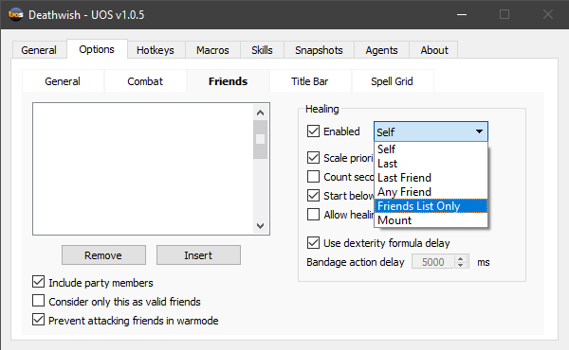

*\*\*\*When you change from [Self] to [Friends List Only] or any other healing option, you will no longer heal yourself obviously and this can pose a problem when you are all by yourself. Normally you can’t insert yourself onto your own friends list with the [Insert] button, but there is a way to get around this and you can in fact be on your own list.\*\*\**

* **Adding yourself to your own Friends List**

First thing you need is your characters serial number. On your UO Steam window, select the Macros tab at the top center. Then click the [Object Inspector] button at the bottom.

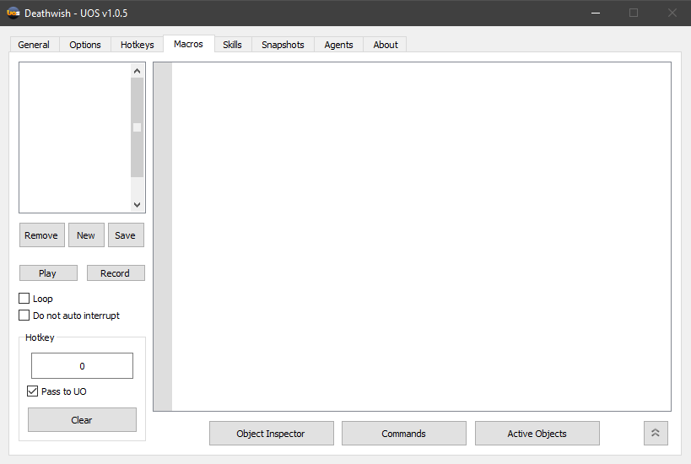

On your game window, target yourself and it will create a window with all the relevant information you need. In this case, your serial number. Either write that number down or you can click it, and ctrl+c to copy it to your clipboard.

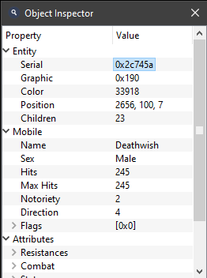

The next step involves editing an XML file in which we add yourself onto your friends list.

By default, the path to the file should be this:

C:\Program Files (x86)\UOS\Profiles

Inside the folder will be an XML file of your characters name.



Open the file using any text editor, (In this case I used WordPad) and it should look something like this:

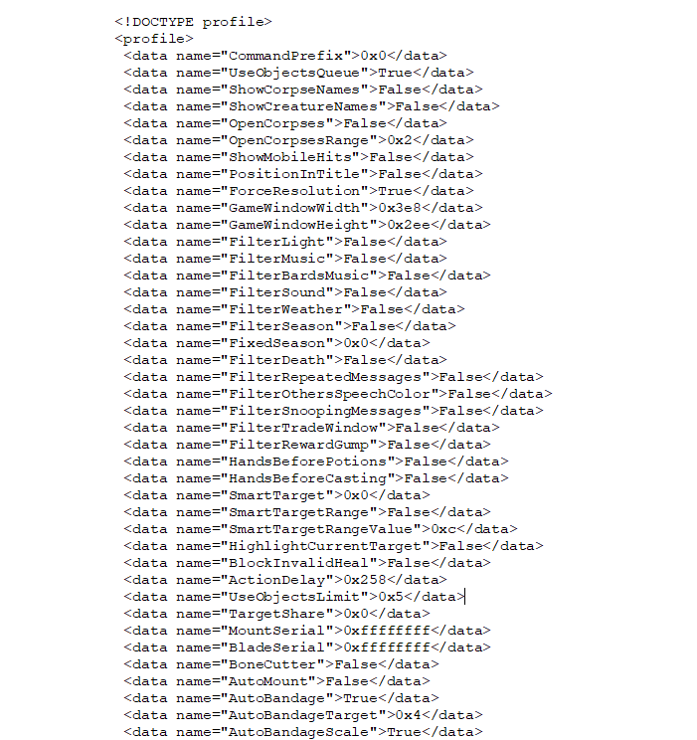

What you are looking for in this file is the line relating to your friends list. Using Ctrl+F and then typing <friends> in the search box will take you to the right spot.

***\*\*\*If you don’t have anyone on your friends list, the XML file will not have the line written in yet. If that is the case, you will have to manually write a few lines in. I recommend adding someone (it doesn’t matter who) to your list and then exit game so that the XML file updates.\*\*\****

To add yourself onto your friends list, follow the format below and add in your serial number to the list like so: <friend name=”YOURNAMEHERE”>YOURSERIALHERE</friend>

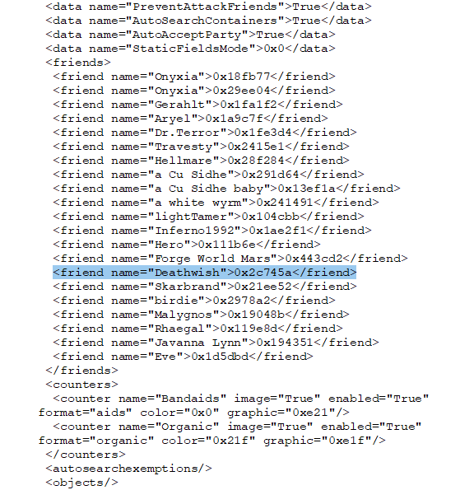

As you can see, I have a list of other players and pets on my list. This will obviously look different for your own XML file. Once done, save and close and you’re all set.

Re-launch UO Steam and log back in and you should now appear on your own friends list and you can keep your heal option set to Friends List Only

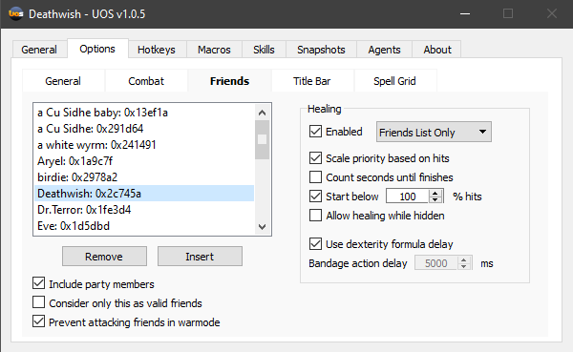

I hope this was clear enough and happy hunting!